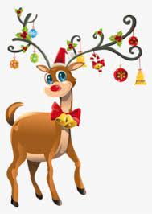 **COME *MEANDER* WITH MARY TO SEE:**

**SPARKLING CHRISTMAS LIGHTS**

Wednesday, December 11

**$65.00**

*FULL PAYMENT DUE December 5, 2024

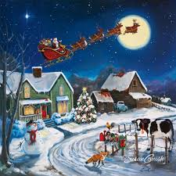 *Questions Please Call Mary Fox: 970-352-4910

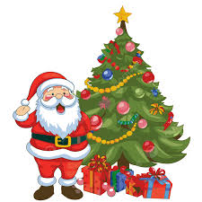 4:00 PM- Depart: Sam’s Club (3247 23rd Avenue; Evans)

5:00 PM- Depart: Park-n-Ride 119 (Southeast Side)

5:30 PM- Cinzzetti’s Italian Market Restaurant (Included)

7:00 PM- Broomfield and Downtown Light Tour

9:00 PM- Light Tour Concludes

9:30 PM- Park-n-Ride Drop Off

10:30 PM- Evans Drop Off

**PLEASE SAVE ITINERARY FOR YOUR REFERENCE!**

**PLEASE CUT AND MAIL REGISTRATION FORM AND PAYMENT TO:**

[](http://images.search.yahoo.com/images/view;_ylt=A0PDoQ26Z2NQDQYA9lKJzbkF;_ylu=X3oDMTBlMTQ4cGxyBHNlYwNzcgRzbGsDaW1n?back=http://images.search.yahoo.com/search/images?_adv_prop=image&va=christmas+lights+clip+art&fr=fp-yie8&tab=organic&ri=13&w=425&h=102&imgurl=abkldesigns.com/pn9.gif&rurl=http://abkldesigns.com/xmas20.html&size=5.7+KB&name=clip+art+dividers+Christmas+mugs+gingerbread+cookies+Christmas+lights+...&p=christmas+lights+clip+art&oid=80fae5aecc9978b66c13392352080586&fr2=&fr=fp-yie8&tt=clip+art+dividers+Christmas+mugs+gingerbread+cookies+Christmas+lights+...&b=0&ni=48&no=13&ts=&tab=organic&sigr=112oqrgno&sigb=13ml3itco&sigi=10n3irr6u&.crumb=KpMi.AE.3B5)

Meandering With Mary PO Box 425 Kersey, CO 80644

NAME____________________________TOUR: CHRISTMAS LIGHT TOUR_________________

PICK UP LOCATION_____________________________________PHONE___________________

PREFERENCE DATE______________________________________________________________